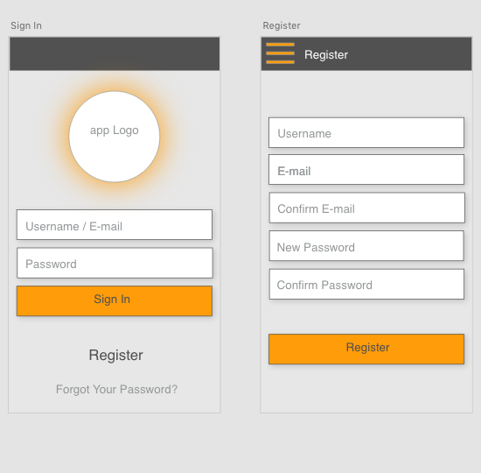

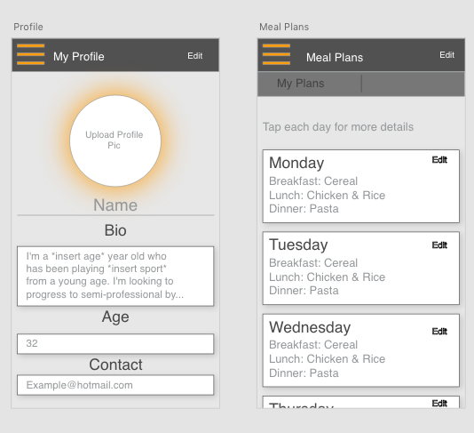

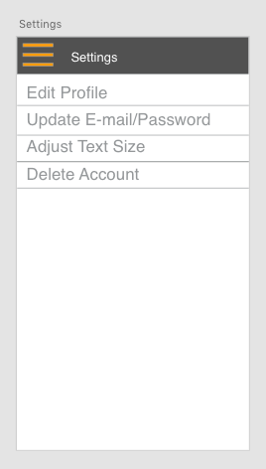

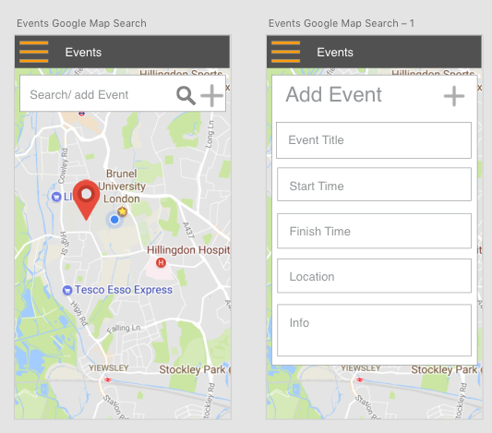

**Requirements**

Please use MYSQL and PHP admin for the database. Connected to the app

Sign in and register page linked to database

* Authentication , prompt user wrong details have been entered.

Profile page can be edited and updates to each unique user.

Settings page should let me:

* Edit profile
* Update email and password
* Adjust text size for visually impaired people
* Let’s you delete account

Meal plans page:

* Has boxes which lets you add meals Monday to Sunday as shown in the pictures
* Each box is for another day of the week
* When clicked on one of the boxes should show more details
* Also linked to database for each user and updates accordingly

Events page:

* Let’s you add markers on the map.
* Shows event title and marker on the map once an event is added
* When you click on the marker it shows more details such as start time and finish time and location.
* Let’s users **search** active events
* Let’s user who added the event delete the event and only the user who added the event on the map can delete the event off the map.
* Automatically deletes event off map if on their longer than 24 hours